The Road to Hades
Matthew Woodward
GAME 2319

Table of Contents
Table of Contents 2
Backstory 3
Exterior Level Design Map 4
Description of Objectives 4
Game Play Walkthrough 5
Primary Art Assets Concept 6
Win and Lose Conditions 6
Secondary Art Assets Concept 7
GUI Design Assets Concept 8
HUD Elements Description 8
Enemy Art Assets 9
Enemies Description 9
Interactive Art Assets 10-11
Interactive Descriptions 10-11

Backstory
Hercules has finished his 11th labor. Now it is time for him to finish his last. Hercules must venture through the Underworld in search of Hades, whom he must convince to allow him to take Cerberus. Hercules has found the entrance to the Underworld and has entered. Now, it is time for you to muster up your courage and complete your final labor. You must search the endless abyss of the Realm of Hades in search of its ruler, Hades himself.
Level Map

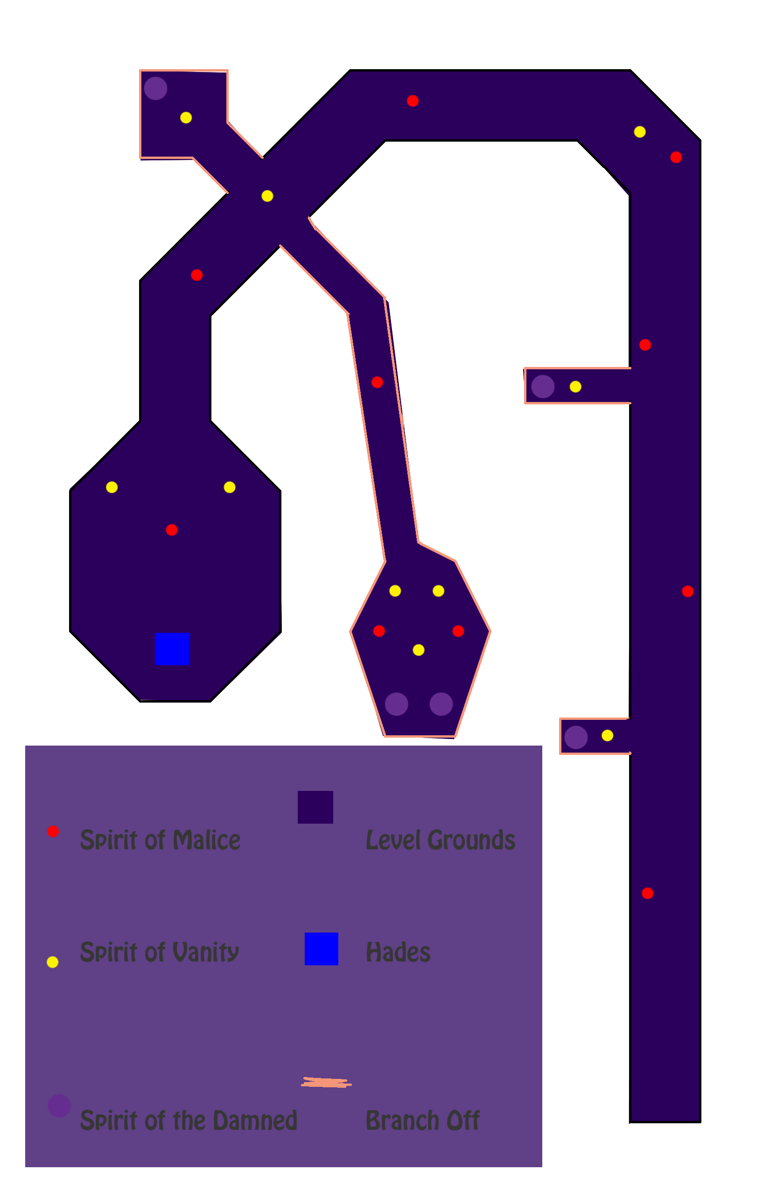
Objectives
A. Survive the evil Spirits.
Spirits haunt every little crevice in the Underworld, be careful to avoid the bad ones.
B. Gather the souls of the Damned.
Damned souls that cannot find their way can be found throughout the Underworld, guide them to Hades so he can punish them accordingly.
C. Find Hades
You must find Hades and convince him to allow you to take Cerberus. Only then will you be able to complete your journey.
Walkthrough
When you start out, walk forward until you reach the first branch off. Either avoid or kill the spirits there and pick up the spirit of the Damned. After exiting the branch off, continue forward until you reach the second branch off, avoiding or killing the spirits as needed. Take the second branch off and gather the spirit of the Damned. Exit the branch off and continue going through the level until you reach the last two branch offs. The left branch off will have two spirits of the Damned. Gather both from the left and the one from the right, and get back on the main grounds. Continue until you reach Hades. Once you reach Hades, you will have completed all of your goals as long as you have gathered all 5 of the spirits of the Damned.
Primary Art Assets
Throne of Hades-
The mysterious throne that Hades himself sits in, said to only suit Hades
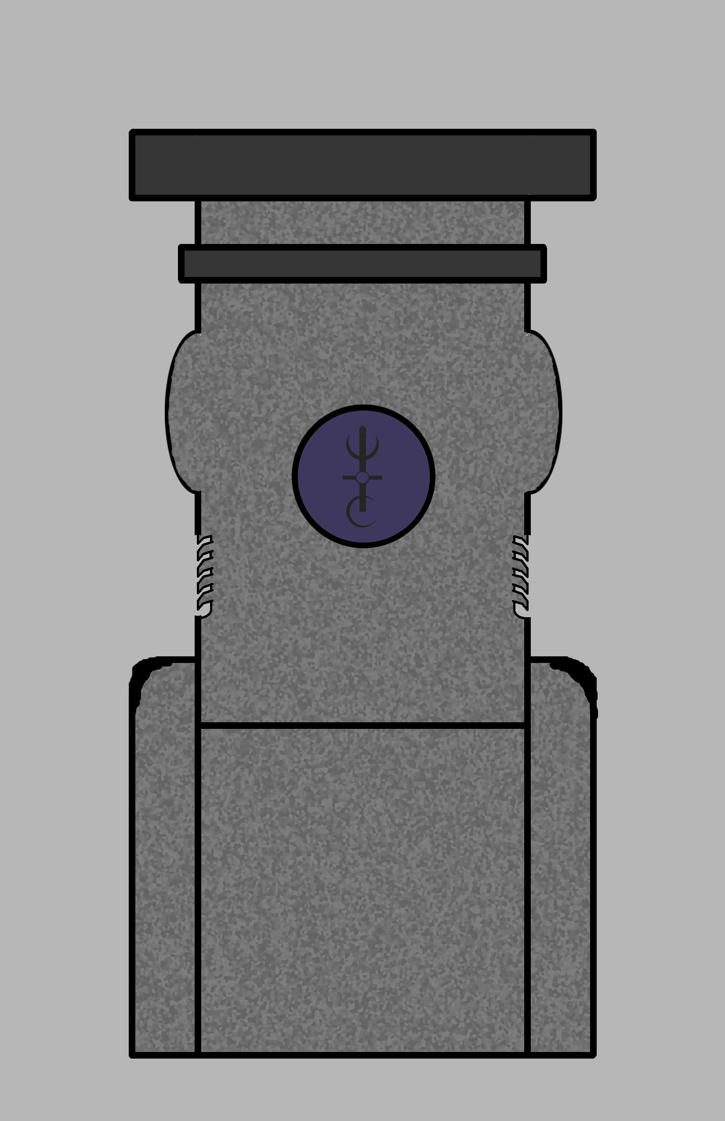
Win and Lose Conditions
Win Scenario-
You successfully collected the souls of the Damned, made your way to Hades, and avoided the eternal visit.
Lose Scenario-
The spirits drag you down - well figuratively, you're already in the Underworld so they couldn't actually drag you down any further but they have succeeded in killing you so now it's a permanent stay and not a visit. You have failed to find inner peace and forgiveness. You die if you lose all 100 of your health.
Secondary Art Assets
Torch- Decorative, used for lighting, hung on walls
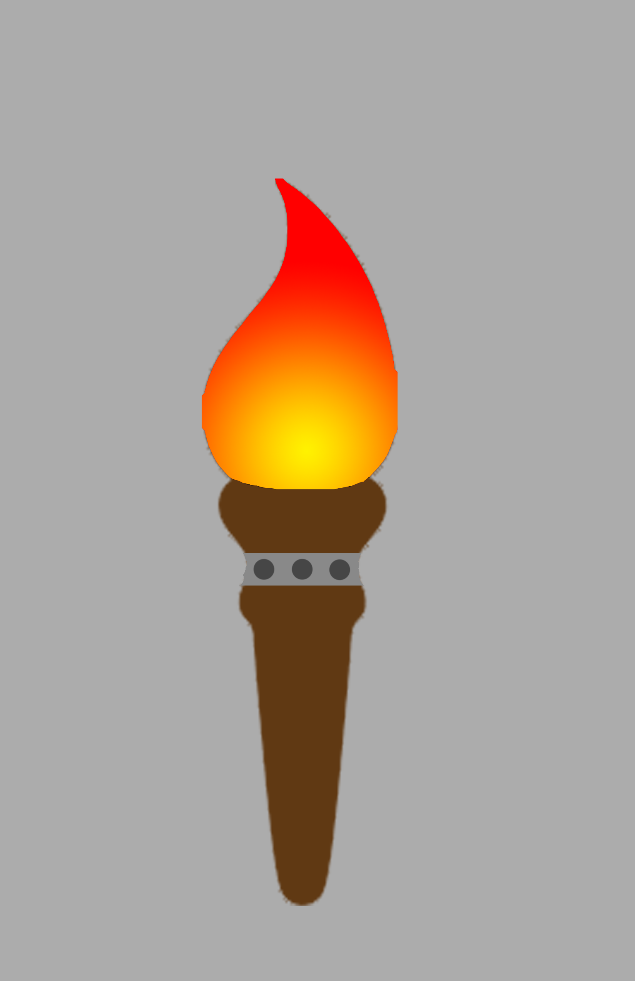
Lantern- Kept in the same room as Hades, gives off much light, treasured
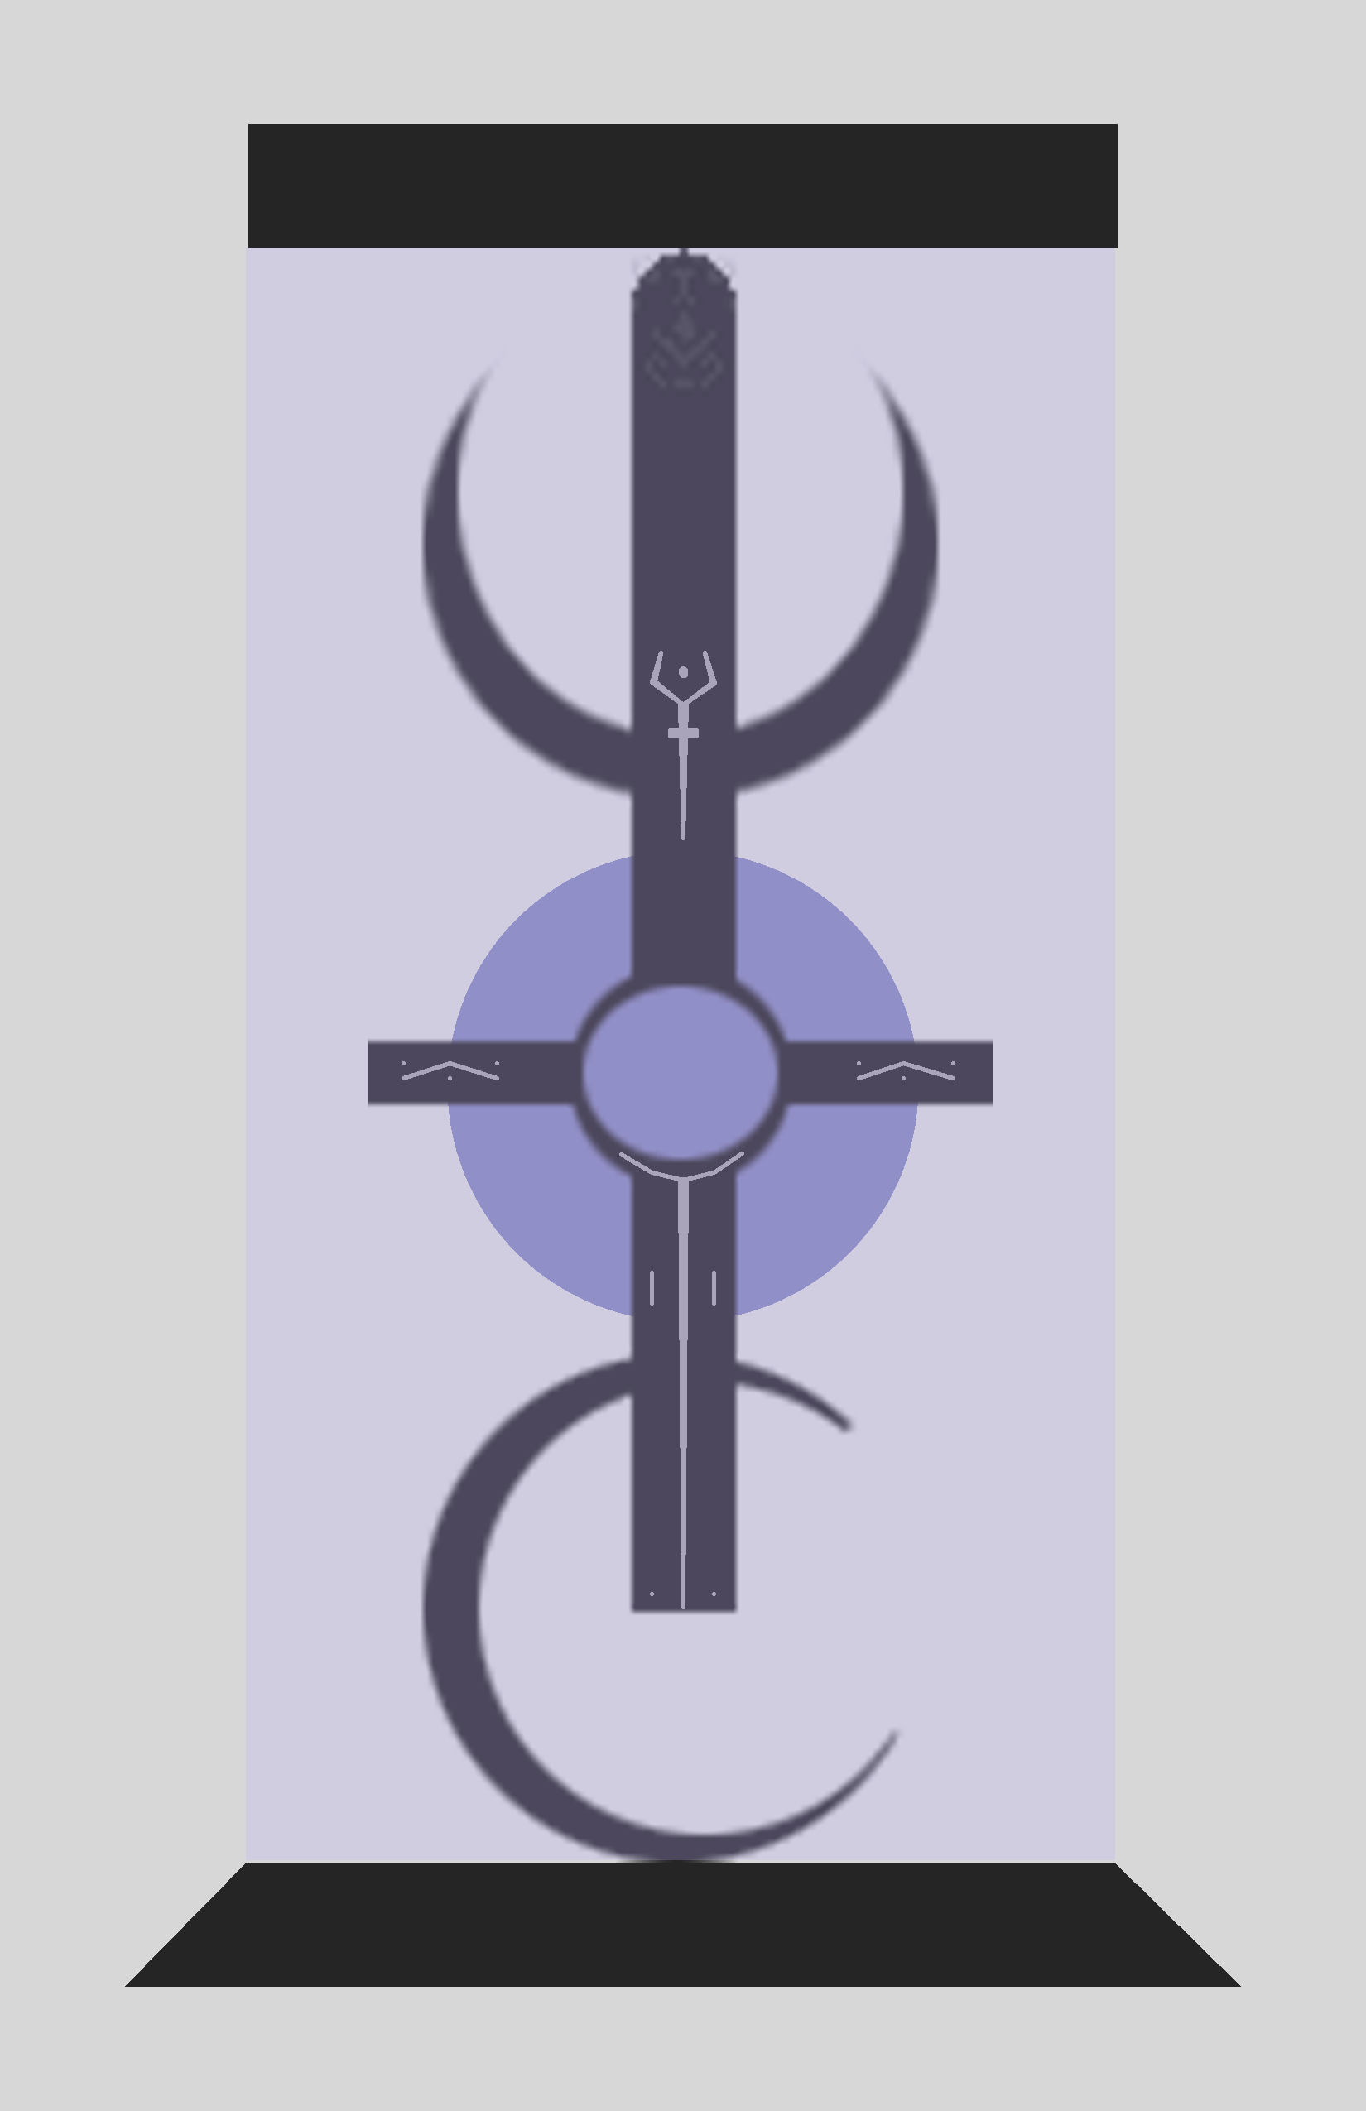
GUI Design
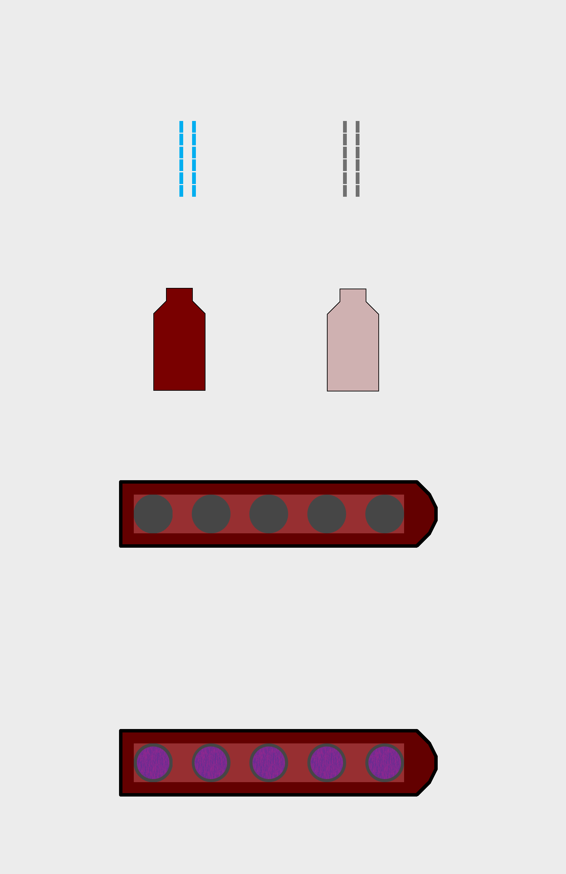

HUD Elements Description
Inventory slots-
The slots will be filled by the souls of the Damned. Each soul will fill up one slot. The GUI will have an ancient look, fitting in to Ancient Greece and mythology.
Visual Health Indicator-
The health indicator will relate to Ancient Greece and Rome, and also with mythology. With Hercules being half God, his health will be represented by a vial of sweet nectar, which the Gods drank, and was said to contain immortality itself.
Visual Ammo Indicator-
Killing souls requires items that are beyond mankind's capability. You are blessed with a sword that can cut down the spirits. However, it loses it's touch with each use and must be refueled. The ammo indicator will be represented by 12 blue bars, each bar representing a single use.

Enemy Art Assets and Description
Spirits of Malice-
The attacking enemies will be the spirits of Malice. As their name suggests, these spirits will hunt you down with malicious intent. These spirits take the form of a person's fears. For Hercules, losing his sanity or failing in his quest are his biggest fears. The spirits, confused, retain their own form, which is the soul form(form can be compared to souls of the Damned), however their malicious intent sets them aside, and gives them a red complex.
Spirits of Vanity-
The attacking turrets will be the spirits of Vanity. These spirits are too prideful to approach you, so they stay back and shoot magic at you. These spirits are basically just floating heads. They will do a random amount of damage. Due to their vanity, these spirits are yellow in nature.

Interactive Art Assets and Description
Ammo Pickup-
The ammo pickup will be represented by a blue potion, made up of different Godly ingredients, and will replenish your sword for 6 uses.

Health Pickups-
The Health Pickup will be represented by a red potion, consisting of the Nectar of the Gods, and will replenish a random amount of health.

In Game Pickups-
The souls of the Damned are the in-game pickups and will fill the inventory slots. There will be 5 souls that need to be taken to Hades. The souls will be purple and round in shape, representing many beliefs of how souls are portrayed.

